### **HTML CSS:**

* HTML stands for:
  + **A. HyperText Markup Language**
  + B. High-Level Text Markup Language
  + C. HyperTransfer Markup Language
  + D. HyperLink and Text Markup Language
* Which HTML tag is used for creating an ordered list?
  + A. <ul>
  + B. <ol>
  + C. <li>
  + D. <dl>
* In CSS, which property is used to change the text color of an element?
  + A. text-color
  + B. color
  + C. font-color
  + D. text-style
* What does the CSS property margin: 10px 20px 15px 5px; represent?
  + A. Top, Right, Bottom, Left margins
  + B. Left, Bottom, Right, Top margins
  + C. Top and Bottom margins only
  + D. Left and Right margins only
* Which HTML tag is used for creating a hyperlink?
  + A. <link>
  + B. <a>
  + C. <hlink>
  + D. <url>
* The CSS property display: inline-block; is used for:
  + A. Displaying elements as a block
  + B. Displaying elements inline with a block layout
  + C. Displaying elements inline with some block-level features
  + D. Hiding elements from the display
* Which HTML tag is used for defining the structure of an HTML document, such as headings and paragraphs?
  + A. <section>
  + B. <body>
  + C. <header>
  + D. <main>
* In CSS, the float property is used for:
  + A. Adding floating elements to the page
  + B. Floating text within a paragraph
  + C. Creating rounded corners
  + D. Positioning an element to the left or right of its containing element
* Which CSS selector is used to select elements with a specific class?
  + A. #class
  + B. .class
  + C. class{}
  + D. classSelector
* What does the HTML attribute alt in the <img> tag represent?
  + A. Alternative text for the image
  + B. Alignment of the image
  + C. Altitude of the image
  + D. Animation level of the image

### **HTML MCQs:**

* What is the purpose of the HTML <meta> tag?
  + A. Define a new meta keyword
  + B. Provide metadata about the HTML document
  + C. Create a new HTML section
  + D. Define a media element
* Which HTML tag is used for creating a table?
  + A. <table>
  + B. <tab>
  + C. <tbl>
  + D. <tr>
* In HTML, which attribute is used to specify the URL of an external stylesheet file?
  + A. src
  + B. link
  + C. href
  + D. style
* Which HTML tag is used for creating an unordered list?
  + A. <ul>
  + B. <ol>
  + C. <li>
  + D. <dl>
* What is the purpose of the HTML <canvas> element?
  + A. Embed audio content
  + B. Embed video content
  + C. Draw graphics using JavaScript
  + D. Define a new font style
* Which HTML tag is used for creating a hyperlink to an email address?
  + A. <email>
  + B. <link>
  + C. <mail>
  + D. <a>
* In HTML, which tag is used for creating a line break?
  + A. <lb>
  + B. <br>
  + C. <break>
  + D. <line>
* What does the HTML attribute colspan represent in a table cell?
  + A. Column span
  + B. Color of the cell
  + C. Content spacing
  + D. Cell padding
* Which HTML tag is used for embedding a video on a webpage?
  + A. <video>
  + B. <media>
  + C. <embed>
  + D. <play>
* What does the HTML attribute target="_blank" do in a hyperlink?
  + A. Opens the link in a new tab or window
  + B. Links to a blank webpage
  + C. Targets a specific element on the same page
  + D. Ignores the hyperlink

### 

* What is the purpose of the CSS property padding?
  + A. Adds space inside the element's border
  + B. Adds space outside the element's border
  + C. Sets the element's font size
  + D. Defines the element's background color
* Which CSS property is used for changing the text alignment within an element?
  + A. text-align
  + B. line-align
  + C. content-align
  + D. align-text
* In CSS, what does the property position: absolute; do?
  + A. Positions the element relative to its normal position
  + B. Positions the element relative to its parent
  + C. Removes the element from the document flow

### 

* Which HTML tag is used for creating a hyperlink to another webpage?
  + A. <link>
  + B. <href>
  + C. <a>
  + D. <url>
* What does the HTML attribute alt in the <img> tag represent?
  + A. Alternative text for the image
  + B. Alignment of the image
  + C. Altitude of the image
  + D. Animation level of the image
* Which HTML tag is used for creating an ordered list?
  + A. <ul>
  + B. <ol>
  + C. <li>
  + D. <dl>
* What does the HTML element <article> represent?
  + A. A navigation menu
  + B. A standalone piece of content that can be distributed and reused
  + C. A section of a page
* In HTML, the <figcaption> tag is used in conjunction with which other HTML element?
  + A. <figure>
  + B. <caption>
  + C. <img>
  + D. <section>
* Which HTML tag is used for creating a form?
  + A. <form>
  + B. <input>
  + C. <label>
  + D. <fieldset>
* What is the purpose of the HTML <aside> element?
  + A. Displaying a sidebar
  + B. Defining a section of navigation links
  + C. Providing additional information or related content
  + D. Creating a header for a section
* Which HTML attribute is used to define the character encoding for the document?
  + A. charset
  + B. encoding
  + C. type
  + D. character
* In HTML, what does the <mark> element represent?
  + A. A highlighted text
  + B. A navigation link
  + C. A code block
  + D. A section of emphasized text
* Which HTML tag is used for creating a horizontal line?
  + A. <line>
  + B. <hr>
  + C. <hrule>
  + D. <hline>
* In HTML, what does the <summary> element represent?
  + A. A section of code
  + B. A summary of the page
  + C. A navigation link
  + D. A summary of details in a <details> element
* Which HTML tag is used for defining the main content of a document?
  + A. <body>
  + B. <main>
  + C. <content>
* What is the purpose of the HTML <abbr> element?
  + A. Creating an abbreviation or acronym
  + B. Adding bold text
  + C. Aligning text
  + D. Displaying a block of code
* Which HTML tag is used for creating a drop-down list?
  + A. <select>
  + B. <list>
  + C. <dropdown>
  + D. <options>
* What is the purpose of the HTML <footer> element?
  + A. Creating a navigation footer
  + B. Defining a page header
  + C. Providing additional information or links related to the content
  + D. Displaying a copyright notice

### 

* In CSS, what does the property margin: 10px 20px 15px 5px; represent?
  + A. Top, Right, Bottom, Left margins
  + B. Left, Bottom, Right, Top margins
  + C. Top and Bottom margins only
  + D. Left and Right margins only
* Which CSS property is used for changing the background color of an element?
  + A. background
  + B. color
  + C. background-color
  + D. bg-color
* In CSS, what does the property position: relative; do?
  + A. Positions the element relative to its normal position
  + B. Positions the element relative to its parent
  + C. Removes the element from the document flow
  + D. Aligns the text within an element
* Which CSS property is used for creating rounded corners?
  + A. corner-radius
  + B. border-radius
  + C. round-corner
  + D. corner-style
* In CSS, the max-width property is used for:
  + A. Setting the maximum font size
  + B. Limiting the maximum width of an element
  + C. Defining the maximum number of lines
  + D. Controlling the maximum height of an element
* Which CSS property is used for changing the font family of text?
  + A. font-style
  + B. font-family
  + C. text-font
  + D. font-type
* In CSS, the float property is used for:
  + A. Adding floating elements to the page
  + B. Floating text within a paragraph
  + C. Creating rounded corners
  + D. Positioning an element to the left or right of its containing element
* What does the CSS property display: inline-block; do?
  + A. Displays elements as a block
  + B. Displays elements inline with a block layout
  + C. Displays elements inline with some block-level features
  + D. Hides elements from the display
* Which CSS property is used for adding a shadow effect to an element's text?
  + A. shadow
  + B. text-shadow
  + C. box-shadow
  + D. element-shadow
* In CSS, what does the property box-sizing: border-box; do?
  + A. Adds extra space outside the element's border
  + B. Adds extra space inside the element's border
  + C. Includes padding and border in the element's total width
  + D. Excludes padding and border from the element's total width
* Which CSS selector is used to select all elements of a specific type?
  + A. *
  + B. #id
  + C. .class
  + D. element
* What is the purpose of the CSS property opacity?
  + A. Controlling the thickness of borders
  + B. Adjusting the transparency of an element
  + C. Defining the space between elements
  + D. Changing the color of text
* Which CSS property is used for changing the text color of an element?
  + A. text-color
  + B. color
  + C. font-color
  + D. text-style
* In CSS, what does the property text-decoration: underline; do?
  + A. Adds a background color to the text
  + B. Underlines the text
  + C. Applies italic style to the text
  + D. Aligns the text
* Which CSS property is used for setting the width of the border of an element?
  + A. border-width
  + B. line-width
  + C. width
  + D. border-size

### 

* What is the purpose of the HTML attribute colspan in a table cell?
  + A. Adds space between table columns
  + B. Sets the column span
  + C. Defines the color of the cell
  + D. Aligns text within the cell
* In CSS, the z-index property is used for:
  + A. Adding space between elements
  + B. Specifying the stacking order of elements
  + C. Creating rounded corners
  + D. Changing the font size
* Which HTML tag is used for creating a definition list?
  + A. <ul>
  + B. <ol>
  + C. <li>
  + D. <dl>
* In CSS, what does the property text-align: center; do?
  + A. Aligns text to the left
  + B. Aligns text to the right
  + C. Centers text horizontally
  + D. Centers text vertically
* Which HTML tag is used for creating a navigation menu?
  + A. <nav>
  + B. <menu>
  + C. <navbar>
  + D. <navigation>
* In CSS, what does the property background-image do?
  + A. Changes the background color of an element
  + B. Adds a background image to an element
  + C. Sets the opacity of the background
  + D. Defines the border image of an element
* Which CSS property is used for controlling the space between lines of text?
  + A. line-spacing
  + B. text-line
  + C. line-height
  + D. text-spacing

### **Exercise 1:**

HTML:

Create a simple HTML page with the following elements:

* Heading with the text "My First Web Page"
* Paragraph with the text "Welcome to the world of web development."

**PROGRAM :**

<!DOCTYPE html>

<html lang="en">

<head>

    <meta charset="UTF-8">

    <meta name="viewport" content="width=device-width, initial-scale=1.0">

    <title>HTML PAGE</title>

</head>

<body>

    <h1>"My First Web Page"</h1>

    <p>Welcome to the world of web development</p>

</body>

</html>

**Output :**

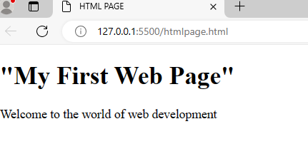

### **Exercise 2:**

HTML:

Create an HTML form with fields for the user's name, email, and a submit button.

CSS:

Style the form to have a centered layout, add some spacing between form elements, and apply different styles to the submit button.

**Html:**

<!DOCTYPE html>

<html lang="en">

<head>

    <meta charset="UTF-8">

    <meta name="viewport" content="width=device-width, initial-scale=1.0">

    <title>FORM SUBMIT</title>

    <link rel="stylesheet" href="form.css">

</head>

<body>

    <div class="content_forms1">

        <form>

            <div class=content-form>

                <label for="user name">user name:</label><br>

                <input type="text" id="user name" name="user name" required><br><br>

            </div>

            <div class="content-form">

                <label for="email">email:</label><br>

                <input type="text" id="email" name="email" required><br><br>

            </div>

            <div class="submit">

                <input type="submit" value="submit">

            </div>

        </form>

    </div>

</body>

</html>

**Css:**

*{

    margin: 0px;

    padding: 0px;

    box-sizing: border-box;

}

body {

    display: flex;

    justify-content: center;

    align-items: center;

    height: 100vh;

}

.content_forms1{

    width: 50%;

    border: 1px solid black;

    border-radius: 10px;

    padding: 20px;

}

 .content_forms1 .content-form input{

    width: 100%;

    padding: 20px;

    border: 1px solid red;

    border-radius: 4px;

}

.submit input{

    width: 100%;

    padding: 20px;

    font-size: 20px;

    background-color:aqua;

    text-align: center;

    border: none;

    color:green;

}

.content_forms1 .content-form label{

    margin-bottom: 8px;

    font-size: 20px;

}

**Output:**

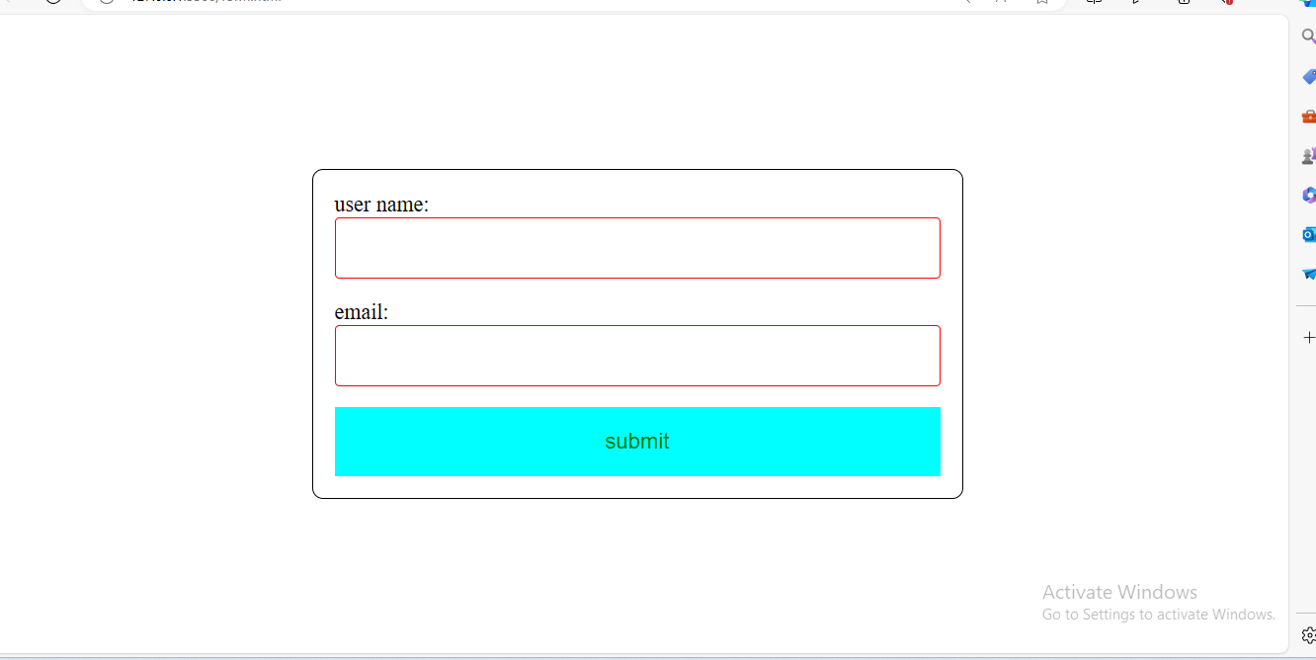

### **Exercise 3:**

HTML:

Create a navigation bar with three links - Home, About, and Contact.

CSS:

Style the navigation bar to have a background color, display the links horizontally, and add some

**Html:**

<!DOCTYPE html>

<html lang="en">

<head>

    <meta charset="UTF-8">

    <meta name="viewport" content="width=device-width, initial-scale=1.0">

    <title>Navigation</title>

<link rel="stylesheet" href="nav.css">

</head>

<body>

    <nav>

        <ul>

            <li>home

            </li>

            <li>about</li>

            <li>contact</li>

        </ul>

    </nav>

</body>

</html>

**Css:**

*{

    margin: 0px;

    padding: 0px;

    box-sizing: border-box;

}

nav ul li{

    display: inline-block;

    padding: 15px 15px;

}

nav {

    background-color: aqua;

}

**Output:**

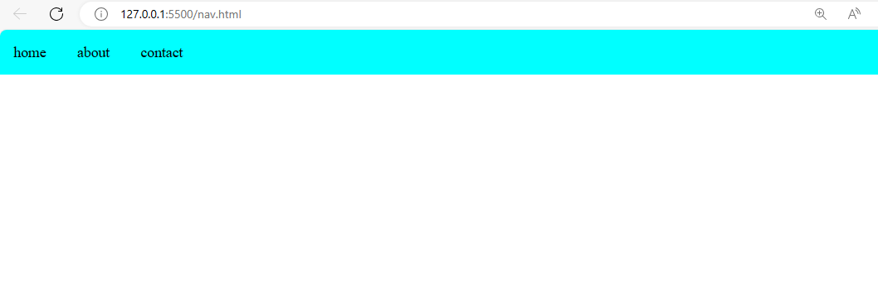

### **Exercise 4:**

HTML:

Create a simple HTML page with an image.

CSS:

Style the image to have a border, rounded corners, and a box shadow.

**Html:**

<!DOCTYPE html>

<html lang="en">

<head>

    <meta charset="UTF-8">

    <meta name="viewport" content="width=device-width, initial-scale=1.0">

    <title>html image</title>

    <link rel="stylesheet" href="image.css">

</head>

<body>

    <div class="image">

        <img src="download.jpeg" alt="greemus">

    </div>

</body>

</html>

**Css:**

*{

    margin: 0px;

    padding: 0px;

    box-sizing: border-box;

}

body{

    display: flex;

    justify-content: center;

    align-items: center;

    height: 100vh;

}

.image{

    border: 2px solid green;

    border-radius: 10px;

    box-shadow: 0 0 30px black;

}

**Output:**

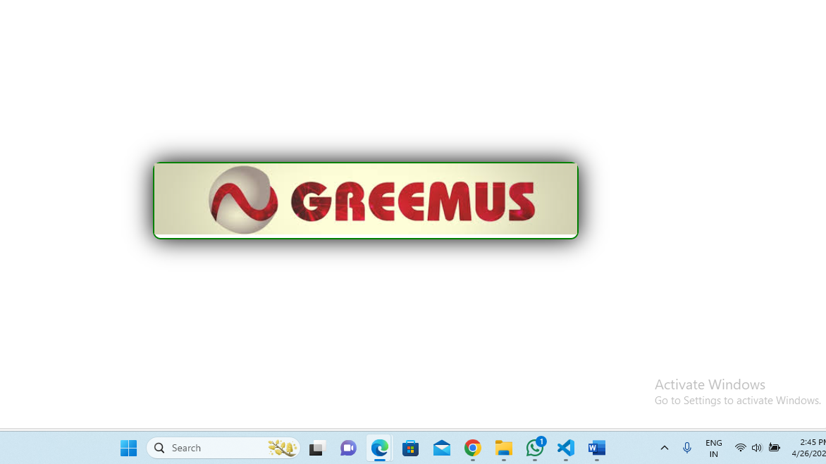

### **Exercise 5:**

HTML:

Create a two-column layout using div elements. Place some content in each column.

CSS:

Style the layout to have a fixed width, add background colors to each column, and apply some margin.

**Html:**

<!DOCTYPE html>

<html lang="en">

<head>

    <meta charset="UTF-8">

    <meta name="viewport" content="width=device-width, initial-scale=1.0">

    <title>element layout</title>

   <link rel="stylesheet" href="element.css">

</head>

<body>

    <div class="reactjs">

        <div class="web_development">

            <p>Web development refers to the process of creating and maintaining websites. It involves designing, coding, and building web pages using programming languages like HTML, CSS, and JavaScript. Web developers also work on the functionality and user experience of websites.

            </p>

        </div>

        <div class="URL">

            <p>URL stands for Uniform Resource Locator. It's like the address of a webpage on the internet. Like website. Web page , files it usually start with http:// or” http://” and followed by the domain and additional path or query parameter . URL’s help us navigate and locate specific content on the web</p>

        </div>

    </div>

</body>

</html>

**Css:**

*{

    margin: 0px;

    padding: 0px;

    box-sizing: border-box;

}

.reactjs{

    width: 50%;

}

.web_development{

    background-color:aquamarine;

    margin: 30px;

    float: left;

    border: 2px solid red;

    padding: 10px 10px;

    border-radius: 5px;

}

.URL{

    background-color:rgb(127, 255, 170);

    margin: 30px;

    float: left;

    border: 2px solid red;

    padding: 10px 10px;

    border-radius: 5px;

}

**Output:**

